**SOFTWARE REQUIREMENTS SPECIFICATION (SRS) FOR CARBON FOOTPRINT CALCULATOR USING MACHINE LEARNING**

**1. Introduction**

**1.1 Document Purpose**

This document defines the functional and non-functional requirements of the Carbon Footprint Calculator, a machine learning-based system designed to estimate an individual's or an organization's carbon footprint. The system provides users with insights into their carbon emissions and suggests actionable steps to reduce their environmental impact.

**1.2 Product Scope**

**The Carbon Footprint Calculator will:**

* Utilize machine learning algorithms to estimate carbon footprint based on user inputs such as energy consumption, transportation habits, diet, and lifestyle choices.
* Provide personalized recommendations for reducing carbon emissions.
* Offer a user-friendly web-based interface for data input and result visualization.
* Integrate with external APIs for retrieving real-time emission factor data.
* Support businesses, policymakers, and individuals in making informed sustainability decisions.

**1.3 Intended Audience and Document Overview**

**Intended Audience:**

* Environmental researchers
* Policymakers and government agencies
* Businesses and organizations looking to reduce their carbon footprint
* Individuals interested in monitoring and reducing their environmental impact

**Document Overview:**

* **Section 1** introduces the document purpose, scope, audience, and conventions.
* **Section 2** provides an overall description of the system.
* **Section 3** details the specific requirements, including functional and interface requirements.
* **Section 4** outlines the non-functional requirements, such as performance and security considerations**.**

**1.4 Definitions, Acronyms, and Abbreviations**

* **Carbon Footprint:** The total amount of greenhouse gases emitted by human activities.
* **ML (Machine Learning):** A branch of artificial intelligence that enables computers to learn from data.
* **API (Application Programming Interface**): A set of functions allowing applications to interact with external services.
* **GDPR (General Data Protection Regulation):** A data protection law governing user privacy in the European Union.

**1.5 Document Conventions**

* Metric units are used for energy, distance, and emissions.
* Machine learning performance is evaluated using accuracy, precision, and recall metrics.
* Data privacy and security guidelines are aligned with industry standards.

**1.6 References and Acknowledgments**

* Intergovernmental Panel on Climate Change (IPCC) Guidelines
* Open-source datasets on carbon emissions
* Research papers on machine learning-based carbon footprint estimation

**2. Overall Description**

**2.1 Product Overview**

The Carbon Footprint Calculator collects user input regarding energy usage, transportation methods, diet, and lifestyle. It then applies machine learning algorithms to estimate carbon emissions and provides actionable recommendations. The results are displayed through a web-based dashboard with interactive visualizations.

**2.2 Product Functionality**

* **User Data Collection:** Users input data related to their energy usage, transport, and consumption habits.
* **Machine Learning Processing:** The system applies predictive models to estimate emissions.
* **Result Visualization:** The system presents a detailed breakdown of the user's carbon footprint.
* **Recommendations:** The system suggests steps to reduce emissions based on user behavior.

**2.3 Design and Implementation Constraints**

* The system must support real-time data processing.
* The ML model should be trained using accurate and diverse datasets.
* The web interface should be responsive and accessible across different devices.

**2.4 Assumptions and Dependencies**

* Users provide accurate and honest data inputs for reliable predictions.
* The system may rely on external APIs for emission factor data.
* The performance of the ML model depends on the quality of training datasets.

**3. Specific Requirements**

**3.1 External Interface Requirements**

* **User Interface**: A web-based interface for data input, analysis, and visualization.
* **API Integration:** Connectivity with external APIs for retrieving emission factor data.
* **Database Storage:** Secure storage for user input and model-generated results.

**3.2 Functional Requirements**

* Allow users to input relevant lifestyle and energy consumption data.
* Process the input using trained ML models to estimate carbon emissions.
* Generate and display a detailed carbon footprint report.
* Provide recommendations for reducing carbon footprint.

**3.3 Use Case Model**

* User inputs lifestyle data.
* System processes data using an ML model.
* System provides a detailed report with recommendations.

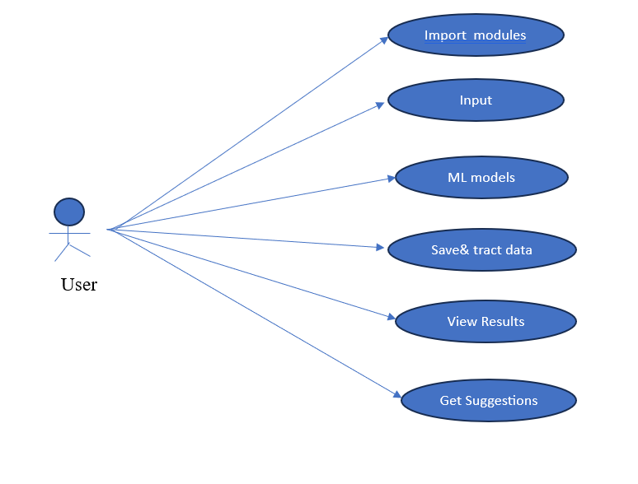

**4. Other Non-functional Requirements**

**4.1 Performance Requirements**

* The ML model should return predictions within 2 seconds.
* The system should support at least 1000 concurrent users.

**4.2 Safety and Security Requirements**

* User data must be encrypted and securely stored.
* The system must comply with GDPR and other relevant data protection laws.

**4.3 Software Quality Attributes**

* **Usability:** The interface should be intuitive and user-friendly.
* **Scalability:** The system should be able to handle increased user demand.
* **Maintainability:** The codebase should be modular and well-documented for future enhancements.

**5. Other Requirements**

* Integration with external environmental databases
* Support for additional emission categories

**Appendix A – Data Dictionary**

|  |  |
| --- | --- |
| **Field Name** | **Description** |
| Energy Usage | User’s electricity and fuel consumption |
| Transportation Mode | Car, bike, public transport details |
| Carbon Emission | Predicted carbon footprint |

**Appendix B - Group Log**

|  |  |  |  |  |  |  |  |  |
| --- | --- | --- | --- | --- | --- | --- | --- | --- |
| |  |  |  | | --- | --- | --- | | Date |  |  | |  |  |  | | Member | Task |
| DD/MM/YYYY | Name | Description |